Written by ketterrm 31AUG2018

**So are you ready to print in color?**

Cura with the Illuminati plugin makes color printing simple! We are going to make it possible assign different colors to each of your color your .stl files.

**Step 1: Set up Cura’s Machine setting so Cura knows that you want 8 colors!**

In Cura select Preferences -> Configure Cura from the pull down menus.

In the Preferences dialog, select printers on the left pane.

Under local printers, select “Custom FDM Printer” and click Add. 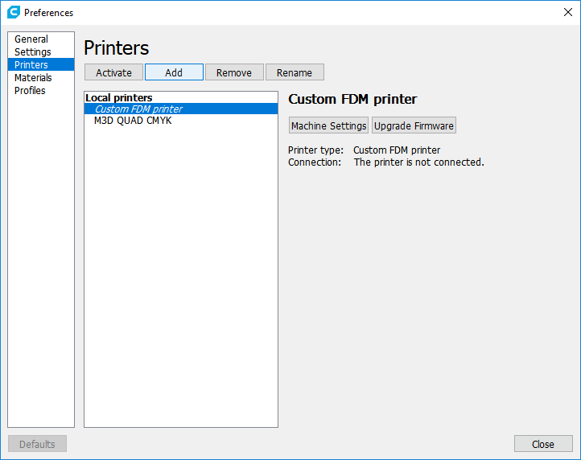

Select Custom FDM Printer and name it “M3D QUAD CMYK” or a name of your choice click Add Printer.

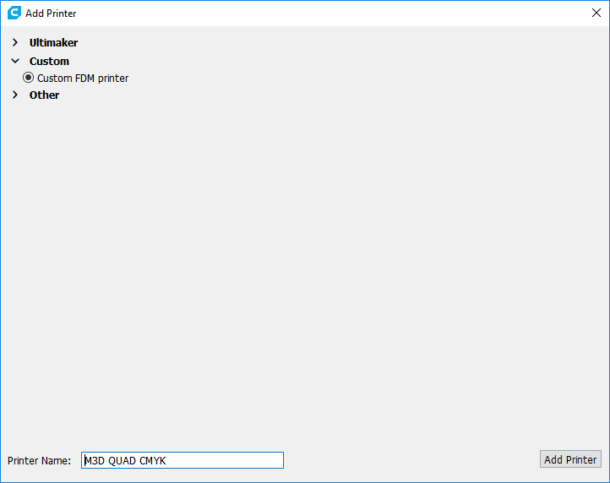

Click Machine Settings:

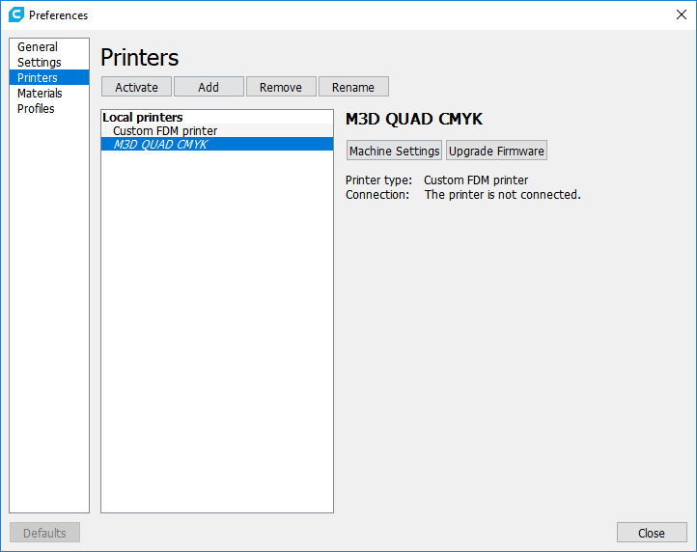

Click Machine settings.

On Printer tab select 8 extruders, and values for the printer settings.

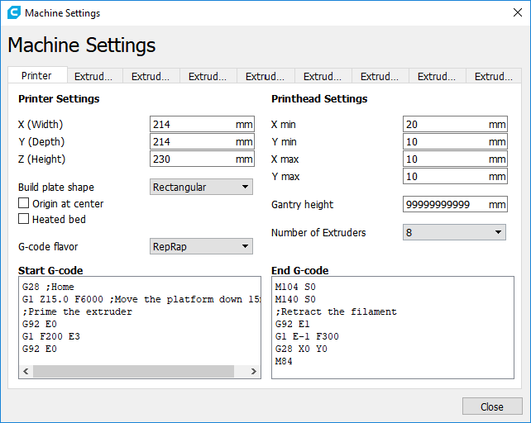

On each of the Extruder tabs update

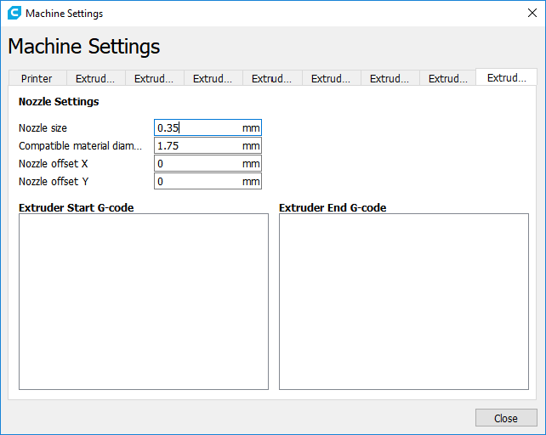

Click Close.

Click Activate

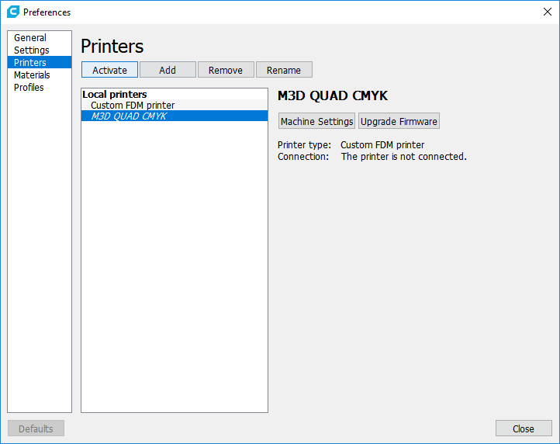

Congratulations. Cura now is set up to use 8 different tools so can print in 8 colors!

Step 2: Set up Materials for visual representation in Cura

Select Extruder 1:

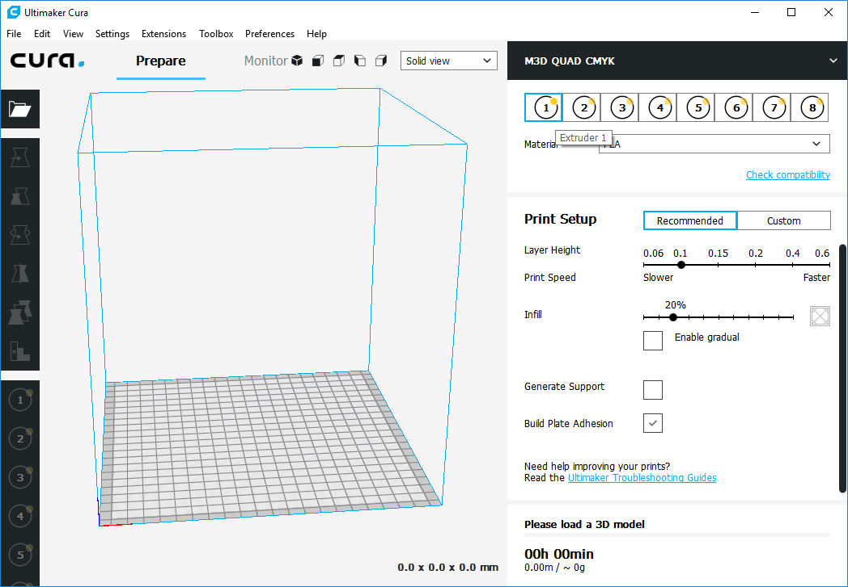

Select the pull down to the right of material and select manage materials.

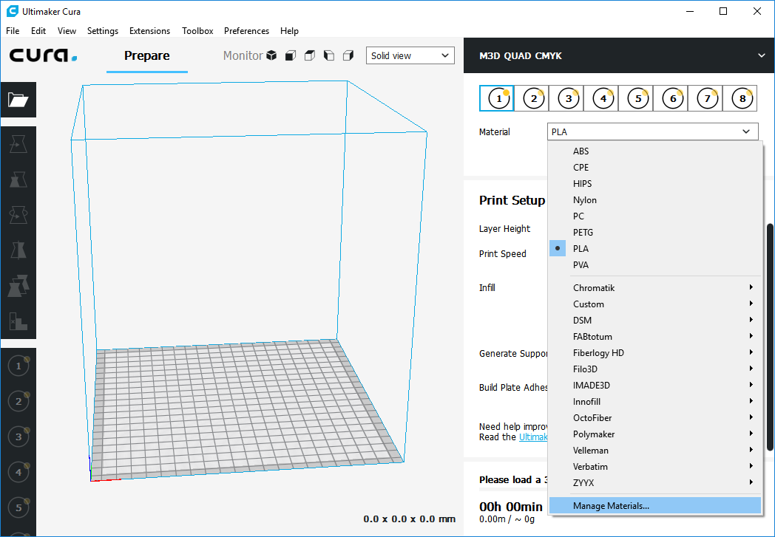

Select any material that resembles CYAN like Generic CPE

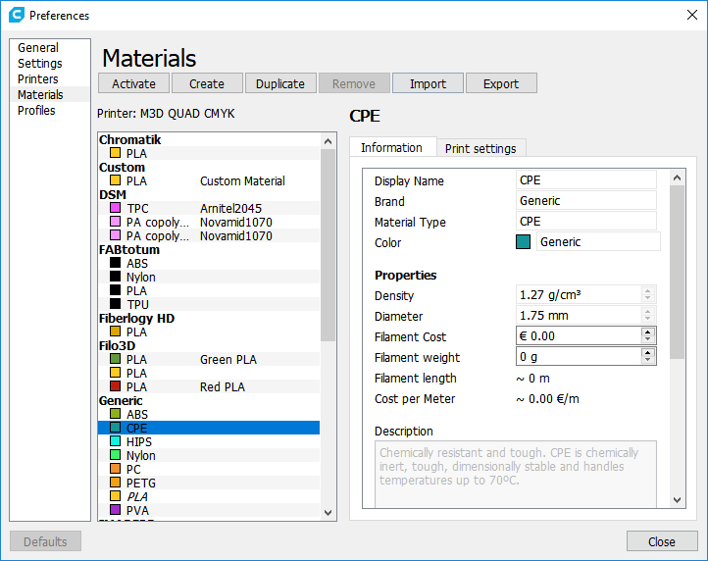

CLICK ACTIVATE. Close dialog.

Extruder 1 now is represented by Blue.

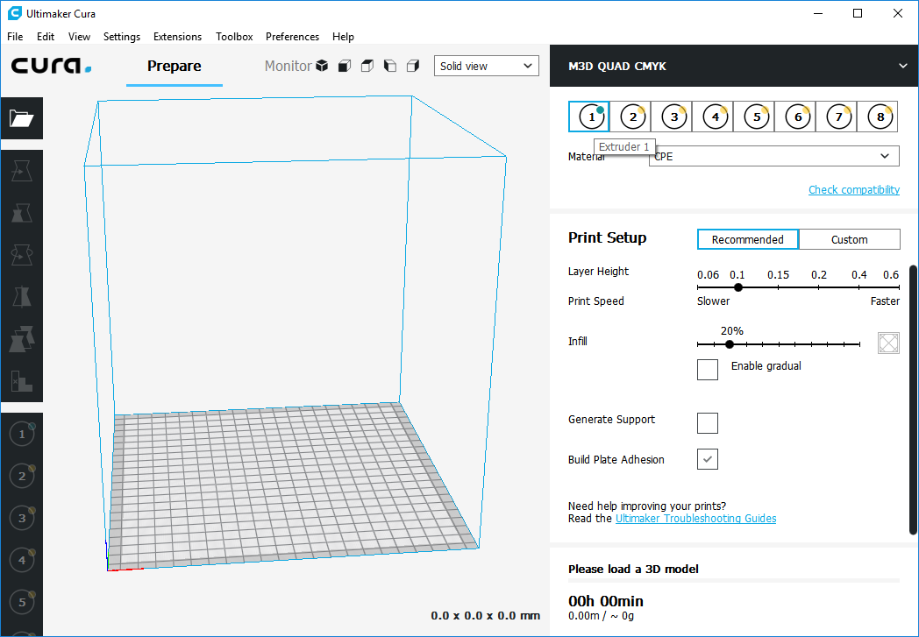

Repeat this process for each extruder.

Set Extruder 2 to Magenta.

Set Extruder 3 to Yellow (already is).

Set Extruder 4 to Key (White).

Set Extruder 5 to Purple.

Set Extruder 6 to Orange.

Set Extruder 7 to Green.

Set Extruder 8 to Brown.

Now all colors should be visible in the color bar.

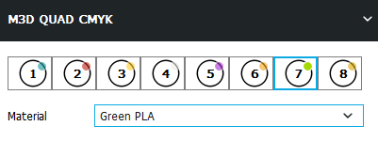

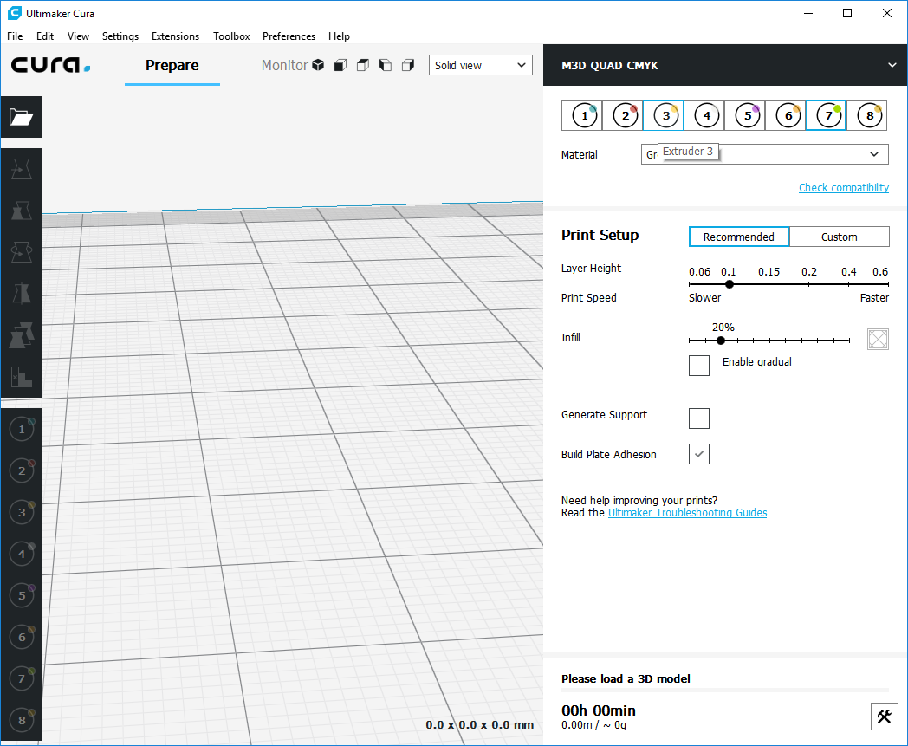

Note: You may create your own custom materials to make a completely accurate representation of the materials, but for our purpose we are trying to just get a representative color so we can preview what the our model will look like in Cura before actually printing it out. We will be later printing out at a fixed temperature, so the material selections here really do not matter.

**Step 3: Time to Color!**

In Cura, load a model that contains multiple .stl files. There are many examples available from public sites such as thingverse. [www.thingverse.com](http://www.thingverse.com) . Searching “multi color” will provide many opportunities to color already existing models.

We will use a globe model as an example

<https://www.thingiverse.com/thing:2242946>

Select download all files.

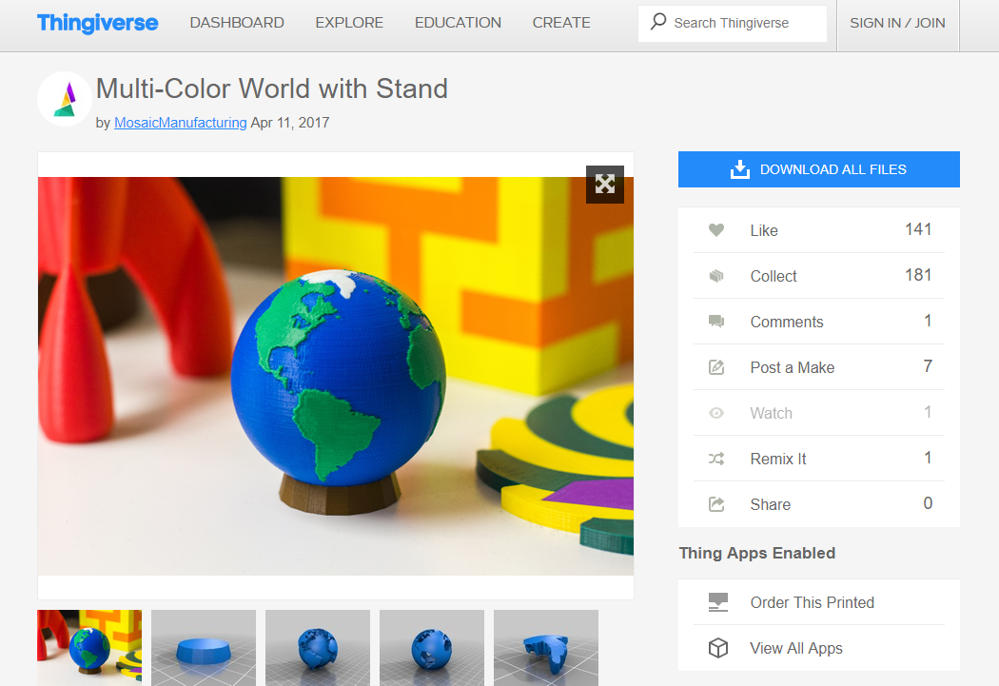

Click extract all:

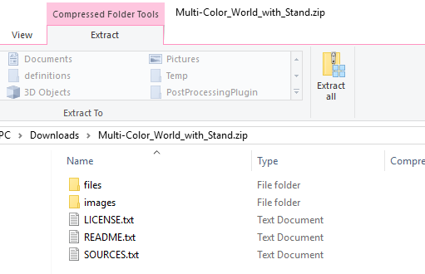

In CURA, Select Open and open all 4 .stl files :

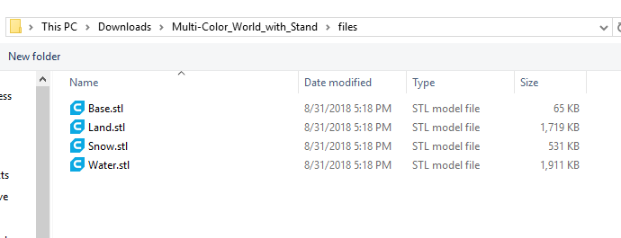

The 4 files will now appear on the build plate:

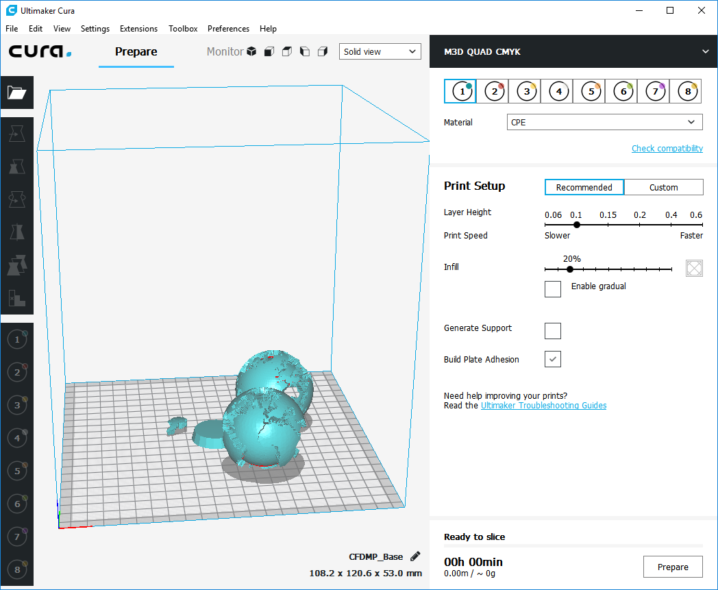

Lets put this together first before coloring.

Select all the parts by selecting CTRL-A.

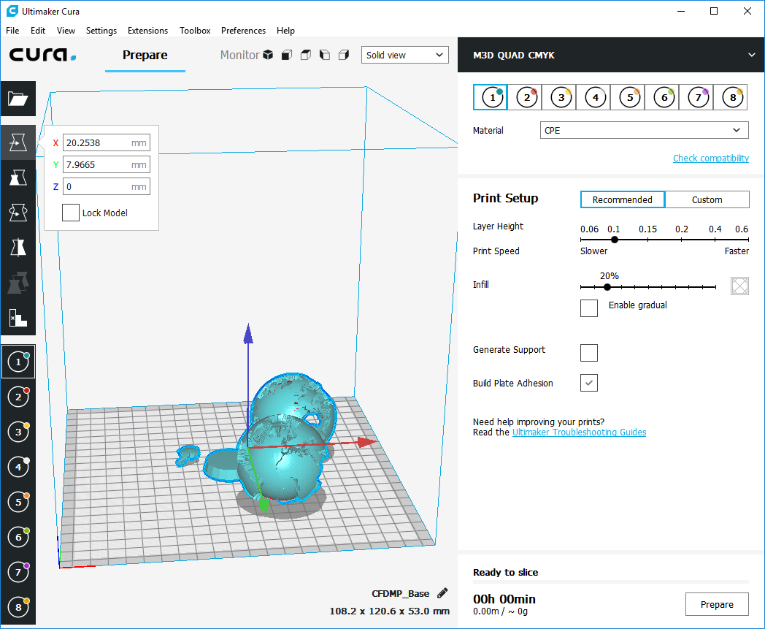

In the edit menu select merge models:

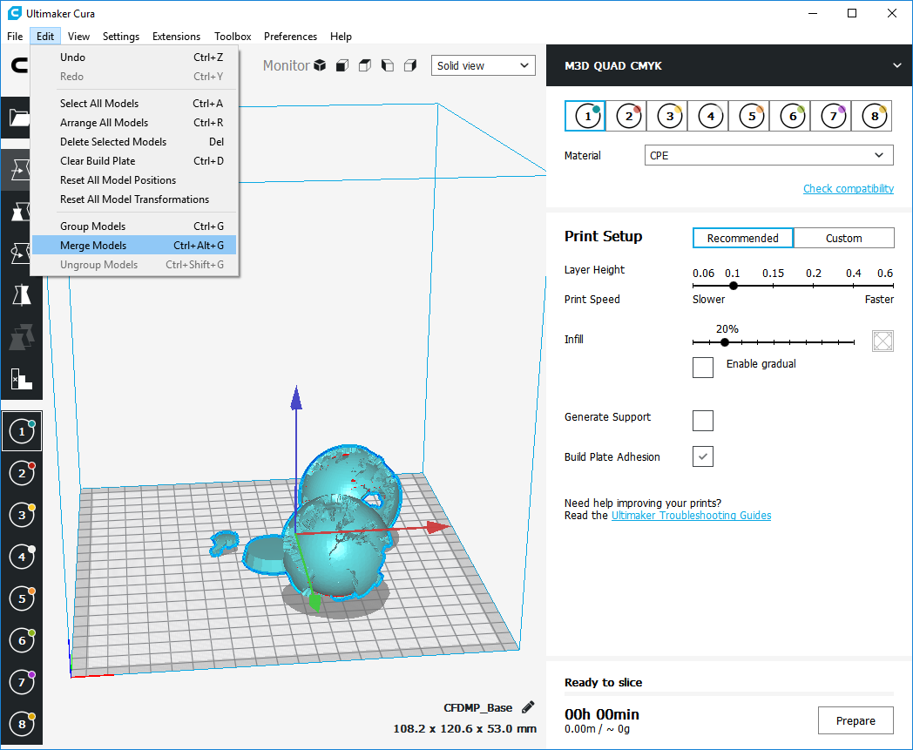

Now the model is put together.

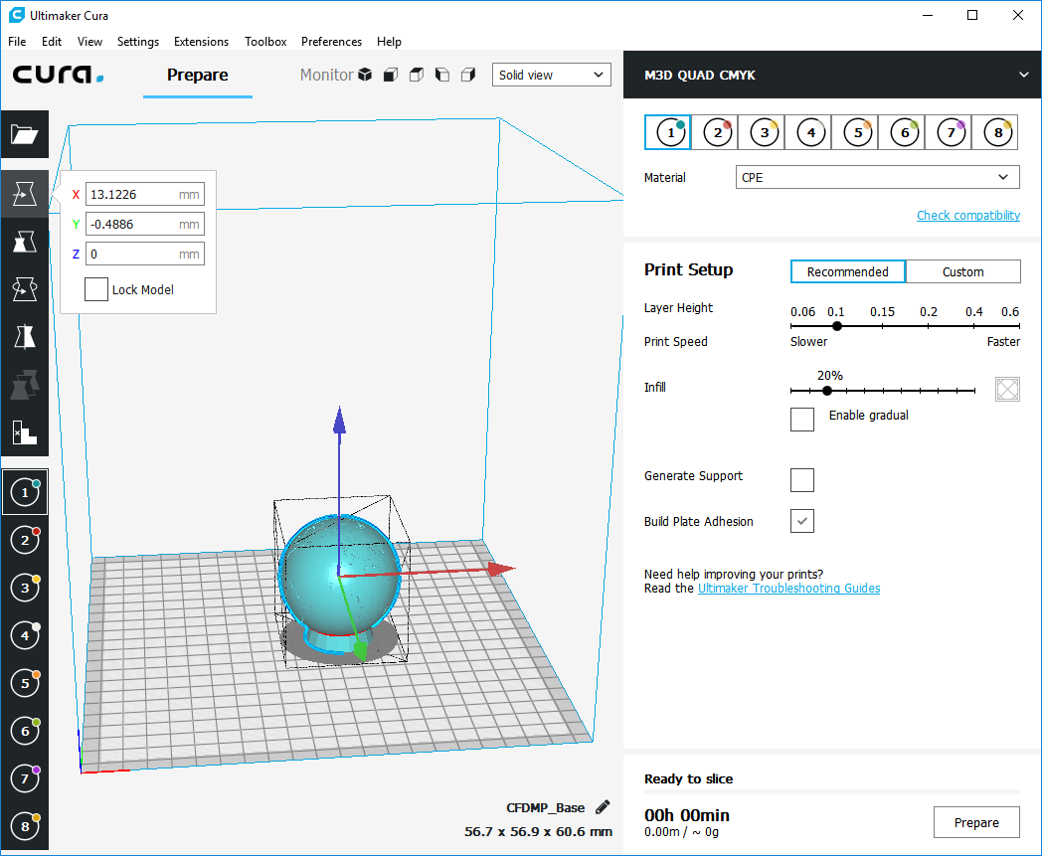

Select the land by holding CTRL and right clicking the land. Click extruder 6 (green) on the left side tool to color.

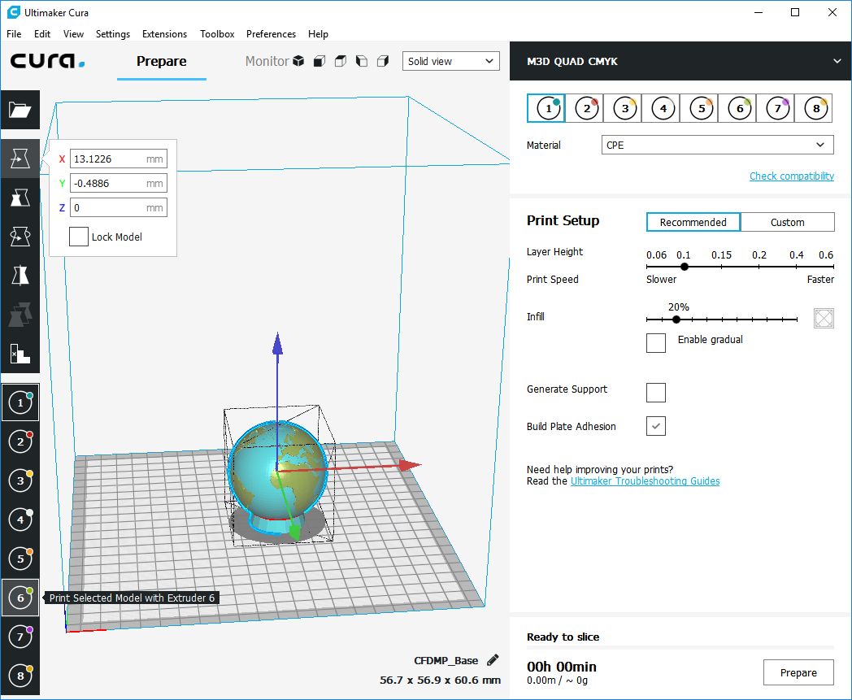

Continue to color the rest of the model. Click on CTRL, right click the base and click extruder 2 for red.

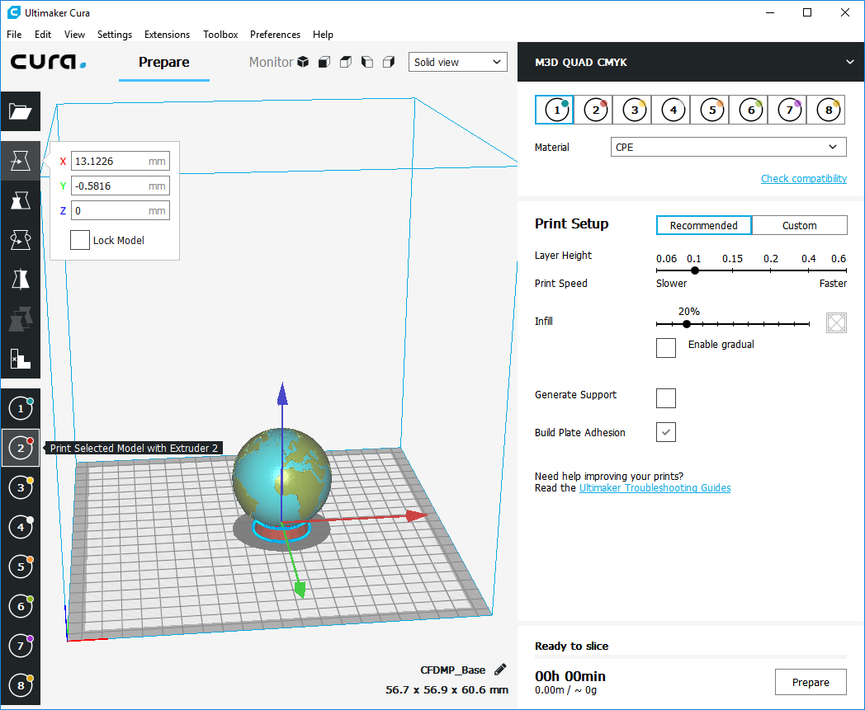

Click on CTRL, right click the base and click extruder 4 for white.

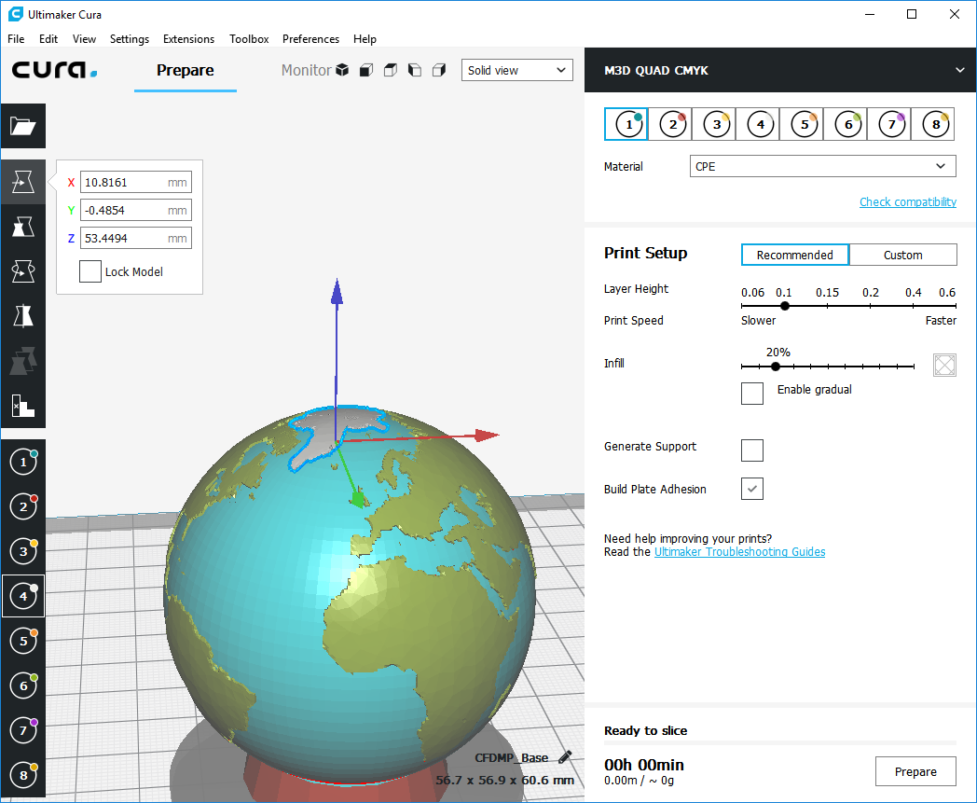

Congratulations. You now can color.

**Step 4: Installing the Illuminati Mixer**

While all may seem well in Cura, this slicer needs some extra information to print with the M3D Quad Fusion Head. We have assigned 8 extruders in Cura, and we need to translate the instructions in the GCODE that Cura will produce to instructions the quad fusion printhead will be able to understand.

To install the plugin go to <https://github.com/ketterrm/Illuminati-Mixer> . click on the download button and down load the zip. 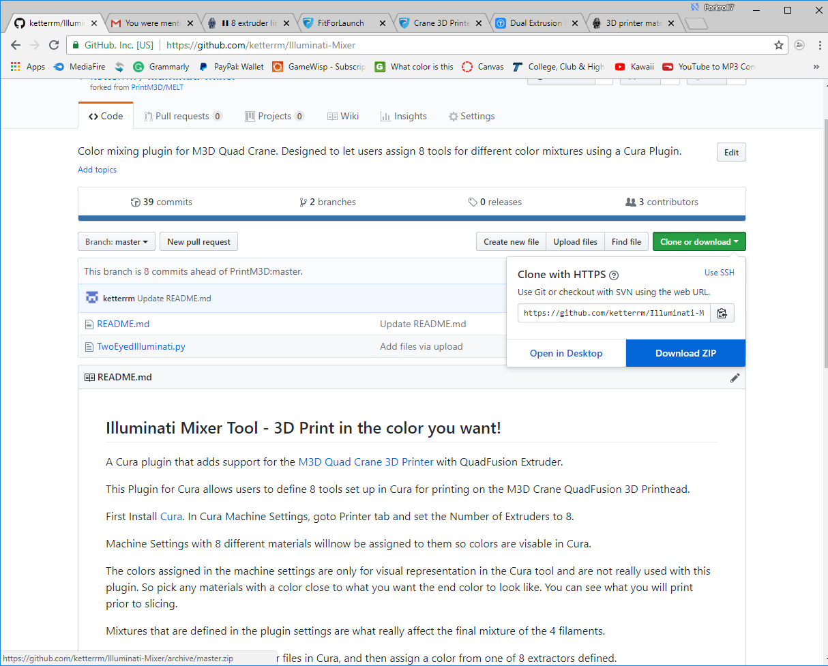 Extract the zip and move the TwoEyedIlluminati.py to the C:\Program Files\Ultimaker Cura 3.4\plugins\PostProcessingPlugin\scripts. Restart Cura.

From the Cura menu select Extensions -> Post Processing -> Modify G-Code

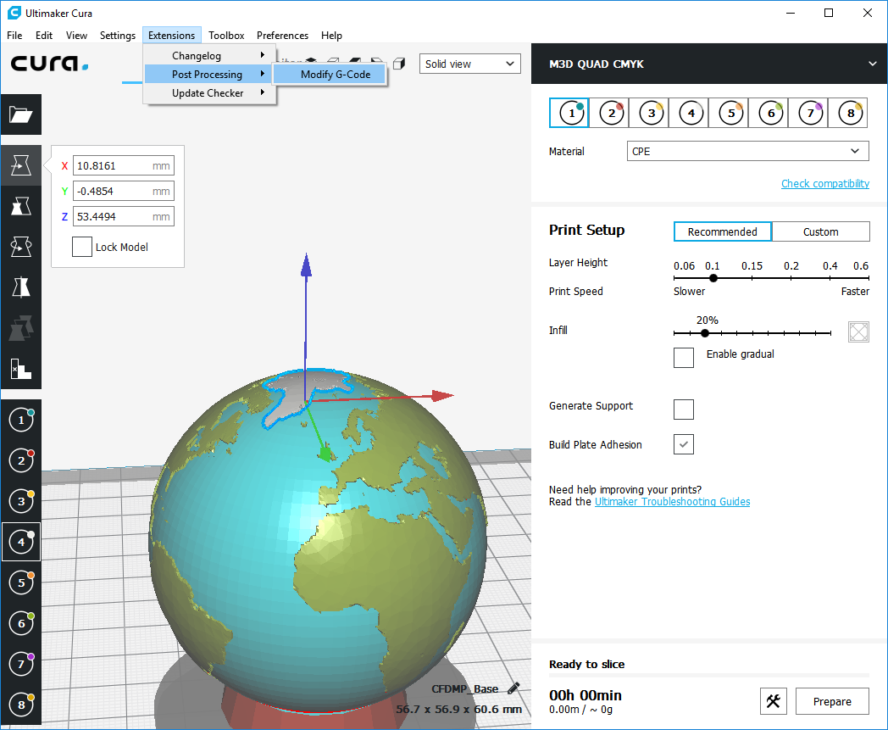

Click Add a script and select the Illuminati Mixer.

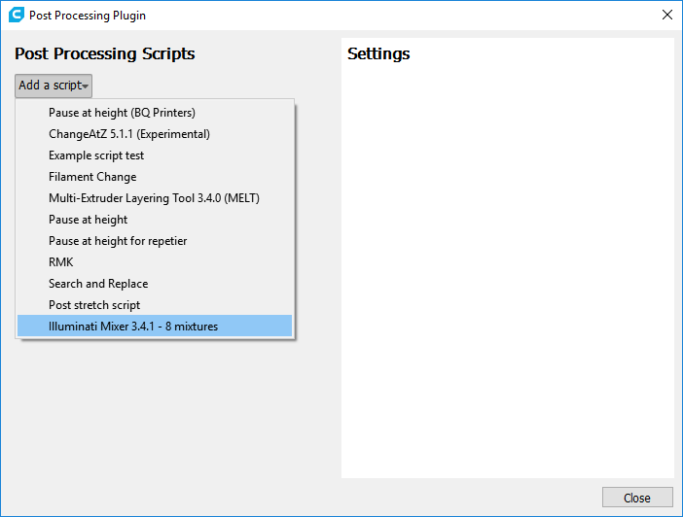

The Illuminati Mixer allows 8 custom mixtures to be defined in terms of a proportion of each of the CMKY filaments.

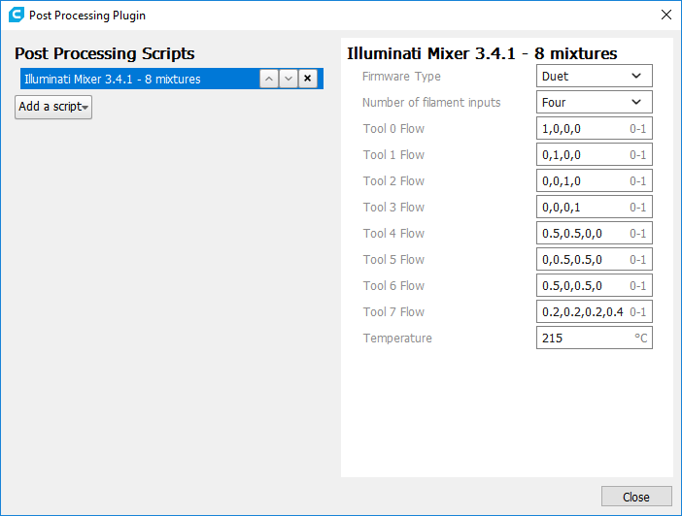

Each of the Tools are defined to represent the portion of flow from each of the 4 Quad Fusion Extractor Trains. For example tool 0 by default is only pulling from the first extruder train, and not the other three. Since we have loaded the Cyan Filament the first, we of course will only get Cyan going through the quad print head. Similar for tool 6, Cyan and Yellow will mix to make Green. The sum of the 4 numbers needs to add to 1.

Temperatures generated by Cura are all overwritten to a single temperature as specified in the plug in. While most multi extruder printers that have multiple physical nozzels that have different temperature, we are allowing that there is only one temperature in the current release.

**Step 5: Get ready to Print**

Scale the model to something small to test with.

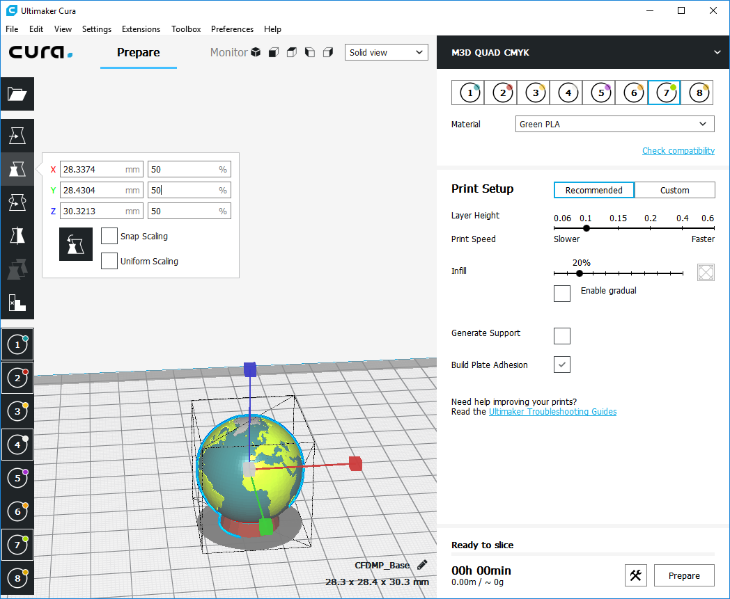

Now that the plugin is on Click the Prepare button to generate the GCODE.

Go to the Layer view to preview the sliced file.

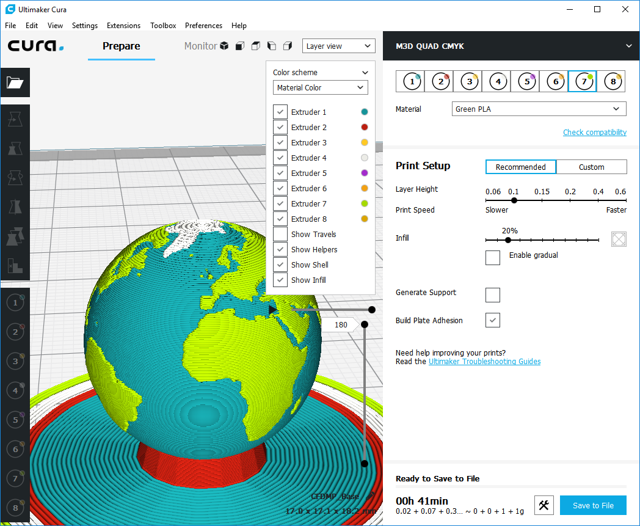

Use the Slider bars to see each layer and simulate.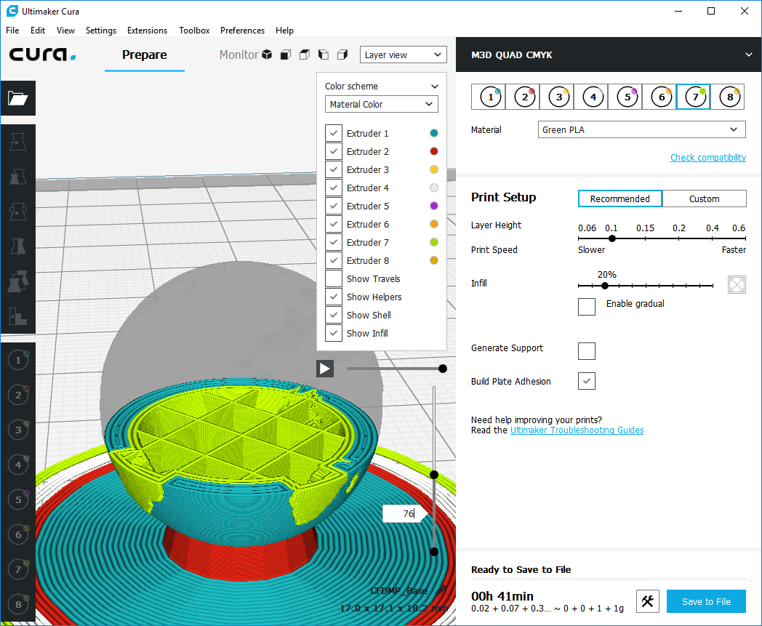

When you are satisfied, Click SAVE to File. You are ready to Print.

Note: There are many other settings to consider in Cura such as if you need Build plate adhesion. Other settings such as head speed will need to be refined once the printer head is available.

Custom Prime Tower – When colors switch, there is some lag between moving between colors. To get a clean color, we suggest you use a prime tower. Cura prime tower options are not ready for using more than 2 extruders at this time. The suggestion is to add your own Prime tower where you can control how large it is and how high it will go. By adding a prime tower onto the build plate before constructing and coloring your model, Cura has been consistently going to the prime tower first before the main model. Check this in your simulation before printing.

2mm Concentric tubes are available at: <https://www.thingiverse.com/thing:3069498>

Using the same merge process as was outlined for creating a model, you can create your custom prime tower to minimize wasted filament. Just as modeling your print is important, modeling a good prime tower will help save filament.

Updating settings in Cura. Note that each of the 8 extractors can have different settings. So if you change the speed of one of the extruders you need to change is for all if you want it to be global. When making a custom setting change you can often right click and select to make the setting applicable to all extruders.

Good Luck .